BERNESE MOUNTAIN DOG CLUB OF NORTHERN CALIFORNIA

Fall Quarterly Membership Meeting

Saturday, September 23, 2023
BBQ II, Hall Park, Dixon

450 Hall Park Drive (Mayes & South Fifth St) Dixon CA
11:00 am – 3:00 pm

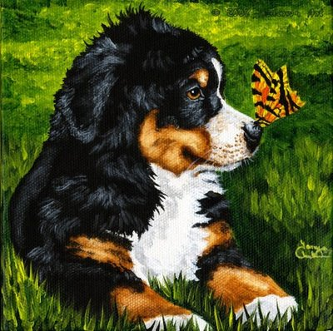

11:00 Arrive: Get settled, mingle, have a nosh.

11:30 Grooming demonstration presented by Toni Beelard

12:30 BBQ: Bring something to throw of the grill. We will supply the fire.

We are going back to potluck!!
Last names starting with M-Z please bring an appetizer to share
Last names starting with A-L please bring a salad or side dish

The club will provide beverages, eating utensils and dessert.

1:30 Membership Meeting Agenda:
Member, Applicant and Guest Sign In
Approval of Minutes
Officer and Committee Reports
Election of new members
Unfinished Business, followed by New Business

Don’t forget leashes, ex-pens and shade.

A Zoom link will be sent out prior to the meeting if you like to attend virtually

