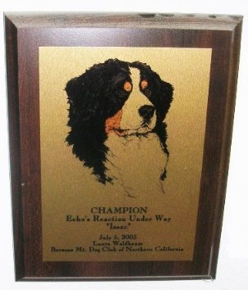
DID YOUR DOG EARN A TITLE OR CERTIFICATE IN 2018? CONGRATULATIONS! YOU MAY BE ELIGIBLE FOR RECOGNITION AT THE BMDCNC ANNUAL AWARDS MEETING
To be eligible for a plaque or certificate you must be a BMDCNC member and the title must be earned by a Bernese Mountain Dog living in the member’s home. All awards must be picked up at the awards meeting.
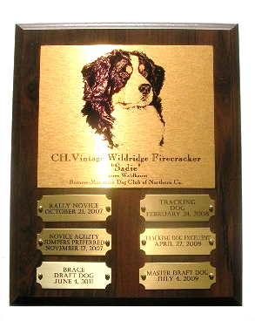
BMDCNC SUPPLIES ONLY ONE PERPETUAL PLAQUE PER DOG. ADDITIONAL PLAQUES MAY BE PURCHASED AT OWNER’S EXPENSE. PLATES WILL BE SUPPLIED FOR EVERY TITLE EARNED. Please contact me for details.
Title Plaques are awarded for titles in: AKC Conformation, Obedience, Rally, Tracking, Agility, Herding, Therapy Dog (THDD title), BMDCA Draft and titles from other organizations such as AHBA, BHA, NACSW, and NADD. Please contact me if the title you earned is not on this list.
Certificates are awarded for: Canine Good Citizen (CGC, CGCA), Herding Instinct, Temperament test, Odor recognition tests, Trick Dog titles, Therapy or Service Dog certification, BMDCA awards such as Top Producer or Achiever, Working Dog awards and Versatility awards, and other similar certifications.
Please note that you have a choice of styles for title plaques – please see the form below. Awards will be presented at the Annual Membership Meeting and Awards Banquet on March 31, 2019. You must pick up your awards/certificates at the meeting or have someone pick them up for you.
PLEASE RETURN ONE FORM FOR EACH TITLE PLAQUE OR CERTIFICATE BY FEBRUARY 28, 2019 TO LAURA WALDBAUM
By Mail: Laura Waldbaum,
BMDCNC Annual Awards
7945 St. Helena Rd. Santa Rosa, CA 95404

By E-mail: laura@waldbaumswildridge.com

Questions (707) 539-5773 (Please no calls after 8pm)

I will contact you to confirm receipt of your form. IF YOU DO NOT HEAR BACK FROM ME WITHIN ONE WEEK OF YOUR SUBMISSION, I DO NOT HAVE YOUR FORM.

BMDCNC AWARD APPLICATION FORM

INFORMATION MUST BE SUBMITTED ON THIS FORM (email completed form, download and mail, or scan and email) AND RECEIVED BY LAURA NO LATER THAN FEBRUARY 28, 2019. NO EXCEPTIONS!!

Dog’s Registered Name Click here to enter text.

Dog’s Call Name Click here to enter text.

BMDCNC Member’s Name Click here to enter text.

Contact info: E-Mail Click here to enter text. Phone Click here to enter text.

Certificate(s) earned in 2018 with date(s) earned Click here to enter text.

Title(s) earned in 2018 with date(s) earned Click here to enter text.

PLAQUES ARE AVAILABLE AS 7” X 9” SINGLE TITLE WOOD PLAQUES OR PERPETUAL TITLE WOOD PLAQUES WITH EITHER 6 METAL TITLE PLATES (8” X 10”) OR 12 METALTITLE PLATES (10” X 13”) WITH EITHER GOLD METAL STOCK ILLUSTRATION - BERNER HEAD OR YOUR DOGS PHOTO ON WHITE METAL (PERPETUAL PLAQUE ONLY) PLEASE SELECT FROM CHOICES BELOW
---------------------------------------------------------------------------------------------------------------------
☐ I already have a perpetual plaque and want to add a new: ☐ title ☐ dog
Please mail a blank plate from your existing plaque with this form.
---------------------------------------------------------------------------------------------------------------------
☐ I would like a single title plaque with stock illustration head study
---------------------------------------------------------------------------------------------------------------------
☐ I would like a 6 PLATE PERPETUAL PLAQUE with:
☐ Stock head study illustration for a SINGLE TITLE (plates will be for different dogs earning the same title)
☐ Stock head study illustration for a SINGLE DOG (plates will be for new titles)
☐ Your Berner’s photo with plates for different titles earned by this dog –
PHOTO MUST ACCOMPANY THIS FORM. Electronic photos must be JPEG format minimum 300dpi
---------------------------------------------------------------------------------------------------------------------
☐ I would like a 12 PLATE PERPETUAL PLAQUE with
☐ Stock head study illustration for a SINGLE TITLE (plates will be for different dogs earning the same title)
☐ Stock head study illustration for a SINGLE DOG (plates will be for new titles)
☐ Your Berner’s photo with plates for different titles earned by this dog –
PHOTO MUST ACCOMPANY THIS FORM. Electronic photos must be JPEG format minimum 300dpi
---------------------------------------------------------------------------------------------------------------------

